7.3: Appendix 3: Interviews

7.3.1: Interview research protocol
Method
Approximately 50 thought leaders and subject matter experts from all relevant perspectives (regulatory, policy, industry, society, startup community and science and technology base) will participate in a semi-structured in-depth interview to assess priorities and fill gaps related to a fully transparent, resilient and fair food system. The semi-structured interview will be informed by a scoping literature review exercise.
Recruitment
Convenience and snowball sampling through the university, consortium and EIT Food networks will be used, as well as through social media in the UK and Europe. Participants will be over the age of 16 who are involved in food system management and the fully transparent, resilient and fair food system agenda: who fall within the following categories:
- Farmers
- Industry (entrepreneurs, startups, SME’s and corporates)
- Government - Policy and regulators
- University and research institutions
- Investors and Funders
- Thought leaders and subject matter experts
- Society (NGO’s, environmental groups, citizens)
The consortium leveraged their strong networks with regional, European, and global agri-food innovation ecosystems to recruit for the questionnaire and interviews. For example, the University of Reading who are a world leading agricultural research institution were notably working on a highly complementary H2020 Pathways projects with over 30 pan-European partners related to the sustainability of European Livestock production; and IfM Engage at University of Cambridge, have an Open Innovation Forum consisting of 20 companies across the whole food and drink value chain. The industry partners, PepsiCo and Kerry are global leaders in the food system. They provided expert input from an industry perspective as well as access to the different trade associations they are well embedded in and access to different players across their supply chain from farmers to retailers and consumers. In addition to this, the EIT Food is a network of over 130 partners in the food system including start-ups, corporates, universities, research institutes and investors. Therefore, EIT Food and its innovation and communication hubs such as Food Hive and Food Unfolded was used to disseminate the survey and workshop invitations. Finally, extensive efforts were put in place to reach and connect with other relevant stakeholders identified through different multipliers and the power of social media.
Data collection
Semi-structured Interview: Participants took part in semi-structured in-depth interviews (lasting approximately 45-minutes) after providing verbal informed consent. All participants received a participant information sheet. The interview topic guide was piloted in (in order to test the content, structure, comprehensibility, and acceptability of the questions) and refined prior to implementation. Interviews took place via Microsoft Teams. Participants agreed to the interviews being recorded for transcription and data analysis and were informed that their identity would remain anonymous, and they would not be identifiable from any quotes used within reports resulting from this research.
Data analysis
A content analysis will be used on interview transcripts to explore the perceptions of thought leaders and subject matter experts from all relevant perspectives (regulatory, policy, industry, start-up community and science and technology base) to assess priorities and fill gaps; and to validate and rank the short list of impact priority areas for a fully transparent, resilient and fair food system.

7.3.2: Interview topic guide
Aim: To develop an understanding of the current barriers to a fully transparent, resilient and fair Food System; and to gather your thoughts on what are the most powerful areas where we can make a difference and transform the food system in the next 3-5 years.
Welcome (2 mins)
Firstly I just want to say thank you for taking part in this interview. My name is X and I am a researcher at XY.
- Firstly I just want to say thank you for taking part in this interview. My name is X and I am a researcher at XY.
- I am talking to different stakeholders across the food system to gather their opinions on the barriers to a fully transparent, resilient and fair food system and to get an insight into how you think we can make a difference and deliver a roadmap to a fully transparent, resilient and fair food system.
- The point of this interview is to understand opinions and views. There are no right or wrong answers, so feel free to be open and honest.
- I would like to use a voice recorder to save me taking lots of notes. Don’t worry, you won’t be personally identified in any of the research outputs or reports. Each participant will be assigned a code and this will be used in reporting. Is this ok?
- After the discussion we will finish with a quick questionnaire.
- Let’s get started!

General Information (8 mins)

- To start can you tell me about your role in the food system?
  - Prompt – Consumer, industry, research, government, solution provider…
  - Prompt – What sector is applicable to their role in the food system?
  - Prompt – What country are they working or living in?

- What is your understanding of a fully transparent, resilient and fair food system?
  - Prompt: Definition of (1) Transparency (2) Resiliency and (3) Fairness
  - Prompt: How would you measure transparency, resilience, and fairness in practice? What are the benchmarks?
  - Prompt: What do you think are the barriers to a fully transparent, resilient and fair food system?
  - Prompt: Do you think it is important take action in this mission area?
  - Prompt: Do you know of any targets or ongoing activities related to achieving a fully transparent, resilient and fair food system?

Key Problems: Trends and drivers (10 minutes)
So now we have reflected on the barriers to a fully transparent, resilient and fair food system and some of the root causes and targets, we would love to hear your thoughts on the biggest trends and drivers influencing the transformation to a fully transparent, resilient and fair food system.

- Looking outside the food sector, what do you see as the biggest Trends & Drivers impacting on a fully transparent, resilient and fair food system?
  - Prompt: And when do you think these will have most impact?
  - Prompt: Timescales: 2023-2025; 2025-2030; 2030-2050
  - Prompt: Consider societal, technological, environmental, economic, political and legal factors
Within the Food & Drink sector, where are the biggest needs or challenges to deliver a fully transparent, resilient and fair food system?
- Prompt: What do you see as the most significant changes / disruptions that might occur that may impact the change to a fully transparent, resilient and fair food system?
- Prompt: And when do you think these will have most impact?
- Prompt: Consider all stakeholders and players across the whole value chain from farm to fork?
- Prompt: Are there new players that we need to consider?

Key Solutions: Value creation opportunities, capabilities and enablers (15 minutes)

- Can you tell me a bit more about what your company / organisation is doing towards achieving a fully transparent, resilient and fair food system?
  - Prompt – What is your policy and strategy?
  - Prompt - What iniatitives or activities have you implemented?
  - Prompt - Are there more plans for the future?
  - Prompt – Now within your role, is there something you do in that space?
  - Prompt: What is the level of impact?

- Could you give us examples of other initiatives or activities that you or your organisation have seen or heard of, that could help achieve a fully transparent, resilient and fair food system?
  - Prompt: What are the biggest opportunities you or your organisation foresee in delivering a fully transparent, resilient and fair food system?
  - Prompt: What are the leverage points within the food system?
  - Prompt: Bear in mind that value could take many forms – commercial or financial, societal, environmental
  - Prompt: Any case studies of things that have and haven’t worked at local, European and international levels?
  - Prompt: And when do you think these will reach widespread adoption?
  - Prompt: What is the level of the impact?

- What will be the most significant technologies and innovations required to deliver these opportunities?
  - Prompt: And when will these be needed?
  - Prompt: Which capabilities are necessary to support and develop these?
  - Prompt: Are there any potential roadblocks?

- What other enablers and resources will be needed for success and to really help you make a difference to the change that is needed for a fully transparent, resilient and fair food system?
  - Prompt: consider legal, regulatory, financial, infrastructure and skills (and indeed anything else necessary)
  - Prompt: And when will these be needed?
  - Prompt: Are there any potential roadblocks?

Final Reflections (5 mins)

- Do you think the food system can become fully transparent, resilient and fair?
- What do you think are the most powerful interventions needed in the next 3-5 years in order to achieve a fully transparent, resilient and fair food system?

- In an idealised world, what would be your key vision for a fully transparent, resilient and fair food system?

Discussion close (5 mins)
Summarise and clarify key points from the discussion.

- Is there anything else you would like to add, that you don’t think we have covered?

Finally, we are interested in gathering as much grey literature and current activity around a roadmap to a fully transparent, resilient and fair food system as possible. Do you know if there are any case studies that have and haven’t worked at local, European and international levels; and any important literature (published and grey) in this space.

- Are there any final examples and links you could signpost us to with other relevant information or activities that we should have a look at?

After interview is complete:
We are carrying out a face-to-face roadmapping workshop in Paris to prioritise opportunities in achieving a fully transparent, resilient and fair food system with key stakeholders.
- Would you be interested in getting involved in the roadmapping exercise?
  - Disclaimer: Not everyone will be selected
  - Record any interest in getting involved.

7.3.3: Interview results
A total of 41 interviews were conducted with a range of stakeholders from various sectors and countries to explore their views on a fully transparent, resilient, and fair food system (further detail of interview participants can be found in appendix X). Most interviews were conducted with stakeholders from Austria (n=17) and Italy (n=10). Stakeholders from Czech Republic (n=6), United Kingdom (n=3), Germany (n=2), France (n=1), Finland (n=1) and the Netherlands (n=1) were also interviewed. Interviewees were primarily from industry (n=18), Universities (n=8) and the third sector (n=6). There was also some representation from Government (n=4), research (n=2), politics (n=1), NGO (n=1) and investors (n=1) amongst the interviewed stakeholders. No stark differences were found between various types of stakeholders during content analysis.

7.3.3a: Key trends and drivers
Quotes from interview participants on the key trends and drivers impacting on a fully transparent, resilient and fair food system:
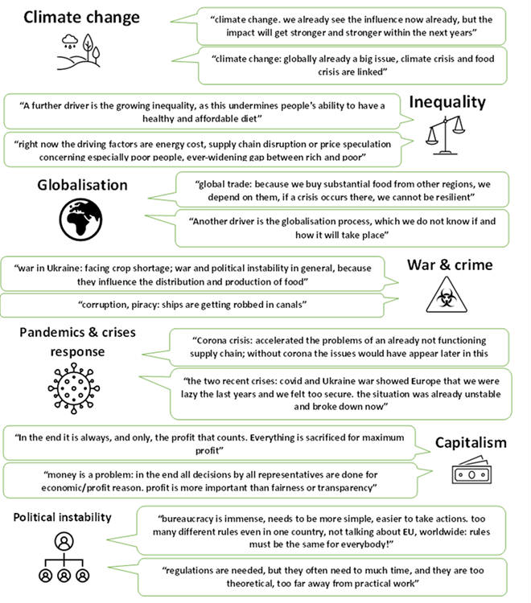
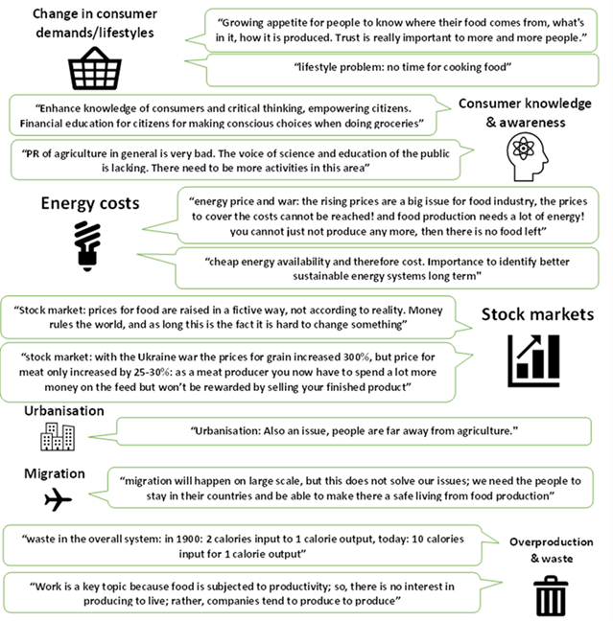

7.3.3b: Key opportunities
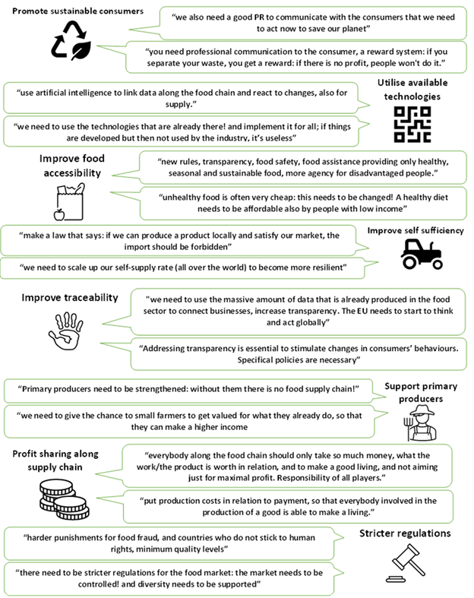
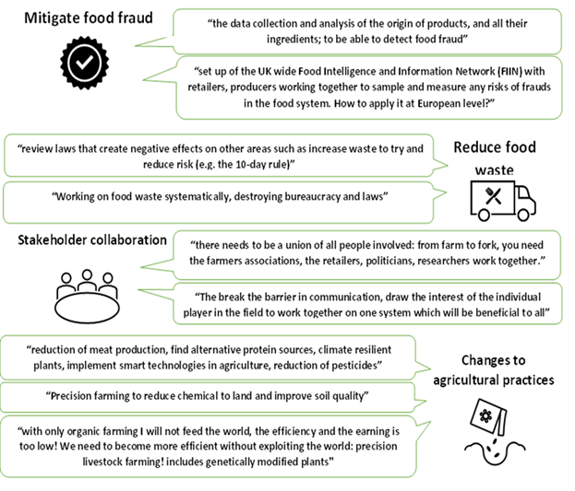

7.3.3c: Key capabilities
Quotes from interview participants on the key technologies and innovations needed to help achieve a fully transparent, resilient and fair food system
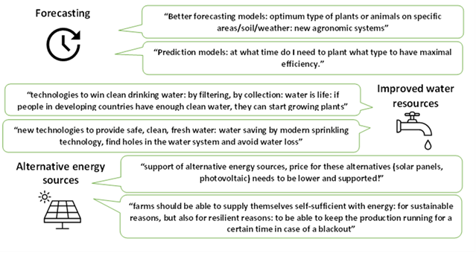
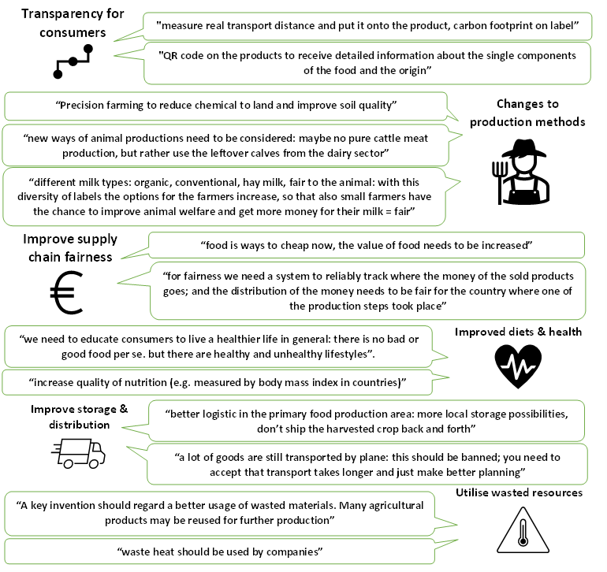

7.3.3d: Key enablers
