7.2: Appendix 2: Questionnaire

7.2.1: Questionnaire protocol
Method
A 15-minute questionnaire with approximately 100-150 stakeholders related to sustainability and the fully transparent, resilient, and fair agenda within the food system will be conducted in order to identify, understand and evaluate the current barriers and opportunities for a fully transparent, resilient and fair food system.
Recruitment
Convenience and snowball sampling through the university, consortium and EIT Food networks will be used, as well as through social media in the UK and Europe. Participants will be over the age of 16 who are involved in food system management and the fully transparent, resilient and fair food system agenda: who fall within the following categories:
- Farmers
- Industry (entrepreneurs, start-ups, SME’s and corporates)
- Government - Policy and regulators
- University and research institutions
- Investors and Funders
- Thought leaders and subject matter experts.
- Society (NGO’s, environmental groups, citizens)
The consortium leveraged their strong networks with regional, European, and global agri-food innovation ecosystems to recruit for the questionnaire and interviews. For example, the University of Reading who are a world leading agricultural research institution were notably working on a highly complementary H2020 Pathways projects with over 30 pan-European partners related to the sustainability of European Livestock production; and IfM Engage at University of Cambridge, have an Open Innovation Forum consisting of 20 companies across the whole food and drink value chain. The industry partners, PepsiCo and Kerry are global leaders in the food system. They provided expert input from an industry perspective as well as access to the different trade associations they are well embedded in and access to different players across their supply chain from farmers to retailers and consumers. In addition to this, the EIT Food is a network of over 130 partners in the food system including start-ups, corporates, universities, research institutes and investors. Therefore, EIT Food and its innovation and communication hubs such as Food Hive and Food Unfolded was used to disseminate the survey and workshop invitations. Finally, extensive efforts were put in place to reach and connect with other relevant stakeholders identified through different multipliers and the power of social media.
Data collection
Participants (n=100-150) will complete an approximate 15-minute online questionnaire. The survey was first piloted (in order to test the content, structure, comprehensibility and acceptability of the programmed questionnaire) and refined prior to implementation. The survey was completed online via Lime Survey. Participants had the opportunity to withdraw from the questionnaire at any time by closing the survey window.
Data analysis
Descriptive statistics (quantitative data) and content analysis (qualitative data) will be performed on the data retrieved from the questionnaire with the aim to identify and understand the current barriers to a Fully Transparent, Resilient and Fair Food System; and to identify and evaluate the potential opportunities and most powerful areas where we can make a difference and transform the food system in the next 3-5 years.

7.2.2: Copy of questionnaire.
1 Basic Demographics
- What is your country of residence?
- What is your gender?
- What is your age?
- What is your highest completed level of education?
- What is your job title?
- Do you work in a domain related to the food system, nutrition or health?
- What best describes your organisation?
2 Vision for a Fully Transparent, Resilient and Fair Food System
Before we begin, we would like to understand what a fully transparent, resilient and fair food system means to you?
Transparent: _______________________________________________________________________
Resilient Food System: _______________________________________________________________
Fair Food System: ___________________________________________________________________
3 Barriers and Challenges to a Fully Transparent, Resilient and Fair Food System
To what extent do you think the following are a barrier to a fully transparent, resilient and fair food system?
 | 1  Not a cause | 2  Insignificant cause | 3  Slight cause | 4  Significant cause | 5  Very significant cause | I don't know
Growing population
Intensive industrialised food production systems
Food Specialization (a small number of plant and animal species supply 90% of the worlds calories)
Global food supply chains
Complex food supply chains
Competitive culture in the food system
Lack of trust
Climate change and emerging risks
Western Diets
Food Waste
Malicious and opportunistic individuals
Organised crime
War and Conflict
Policy and governance
Lack of education and training

Do you think there are any additional root causes or reasons why we do not have a fully transparent, resilient and fair food system?
______________________________________________________________________________________________________________________________________________________________________________________________________________________________________________________
4 Trends Influencing a Fully Transparent, Resilient and Fair Food System
Looking outside the food sector, what do you see as the biggest trends and drivers influencing a fully transparent, resilient and fair food system?
 | No or Insignificant Impact | Short term impact on net zero agenda  (2023-2025) | Medium term impact on the net zero agenda  (2025-2030) | Long term impact on the net zero agenda  (2030-2050)
Growing population
Rapid urbanisation and growth of megacities
Migration of people to other regions
Refugee Crisis, Human trafficking and Exploitation
Labour and skills availability
Work stress and long working hours
Flexible working arrangements
Rising middle class
Rampant Inflation and increases in expenditure for the food industry
Rampant Inflation and increases in non-food expenditure for consumers
Poverty, inequality and social security
Increasing social innovations
A movement towards locally sourced goods
Environmentally Conscious Consumers
Health-Conscious Consumer
Welfare Conscious Consumer
Climate Change
Availability of natural resources
Availability of raw materials
Use of crops for energy or non-food materials (e.g. fiber, for textile)
Cost and availability of cheap fossil fuel energy
Cost and availability of cheap fossil fuel energy
Social media and influencers
Availability of new technologies
Digitalisation
International Trade
Policy
War and conflict

Are there any other trends occurring across the globe that are impacting on a fully transparent, resilient and fair food system?
______________________________________________________________________________________________________________________________________________________________________________________________________________________________________________________
5 Market Needs for a Fully Transparent, Resilient and Fair Food System
From your perspective to what extent are the following market needs in the food system in order to facilitate a fully transparent, resilient and fair food system?
 | Not Needed | Urgently Needed  (2023-2025) | Fair Need  (2025-2030) | Low Need  (2030-2050) | Insignificant or Long Term Need  (Beyond 2050)
Increased Productivity and Profitability
Improving food safety
Ensuring integrity of food supply chains
Food produced to the highest ethical standards
Fair Food Prices
Nutritious food
Assuring fair revenues to primary production sector
Labour Availability
Improving wages and working conditions
Local sourcing
Sustainable farm management techniques
Achieving net zero food production
Water management
Environmentally friendly alternatives to agricultural chemicals (e.g. fertilizers, pesticides, insecticides etc.)
Resiliency to changing weather patterns and natural hazards
Farm machinery and robotics
Data analysis and precision production
Reduction in contaminants (natural or artificial)
Zero emission energy sources
Quantifying emissions
Sustainable packaging
Smart labelling
Traceability and provenance
Food waste reduction
Resource efficiency
Knowledge and skills training
Consumer Education
Consumer insight
Protecting the food system from opportunistic and malicious individuals or organisations
Alternative protein sources (food and feed)
Access to innovation and technology in the food system
Digitalisation of the food system
Big data and artificial intelligence
Evidence based policy
Governance and suitable guardians in the food system

Within the agrifood sector, do you think there are any additional needs or challenges in achieving a fully transparent, resilient and fair food system?
______________________________________________________________________________________________________________________________________________________________________________________________________________________________________________________
6 Value Creation Opportunities towards a Fully Transparent, Resilient and Fair Food System
Please prioritise the opportunities required to deliver value for a fully transparent, resilient and fair food system
 | Urgent Priority (2023-2025) | Fair Priority (2025-2030) | Low Priority (2030-2050) | Insignificant Priority (Beyond 2050) | Not a priority
Sustainable farm management
Sustainable Aquaculture production
Achieving net zero production
Improving animal welfare
Water management
Controlled environment agriculture and vertical farms
Reduction in contaminants (natural and artificial)
Integrated Production Systems
Biological based crop protection
Microbiome technologies for crops and soil
Gene editing technology
Plant-based food alternatives
Cultured and lab-grown food
Synthetic Biology
Robotics, drones and automation
Food sensing and processing
Food Preservation and Smart Food Packaging
Food Labelling
Supply chain distribution and management
Optimizing local food supply chains
Optimizing global food supply chains
Waste Management and Circular Economy
Social Innovations
Digital marketplaces
Consumer Insight
Consumer behaviour and diets
Data and value-chain integration
Robust handheld devices for control of food contaminants
Artificial Intelligence
Computer Vision
Blockchain
Machine Learning
Internet of Things
Virtual Reality
Business models and systems
Evidence-based Policy
Nanotechnology

Are there any additional value creation opportunities in order to ensure a fully transparent, resilient and fair food system?
______________________________________________________________________________________________________________________________________________________________________________________________________________________________________________________
7 Enablers for a fully transparent, resilient and fair food system
What are the priority enablers needed to realise a pathway to a fully transparent, resilient and fair food system?
 | Urgent Priority (2023-2025) | Fair Priority (2025-2030) | Low Priority (2030-2050) | Insignificant Priority (Beyond 2050)
Policy and legislation
Knowledge and skills
Resources and infrastructure
Funding landscape
Collaboration and partnerships
Public Engagement
Research and Innovation

Do you think there are any other enablers required to deliver a fully transparent, resilient and fair food system by 2050?
______________________________________________________________________________________________________________________________________________________________________________________________________________________________________________________
8 Final Reflections
Do you think the food system can become fully transparent, resilient and fair by 2050? And why?
Yes
No
______________________________________________________________________________________________________________________________________________________________________________________________________________________________________________________

What do you think are the most important interventions in the next 10 years in order to achieve a fully transparent, resilient and fair food system by 2050?
______________________________________________________________________________________________________________________________________________________________________________________________________________________________________________________
Finally, we are interested in gathering as much information and activities around a fully transparent, resilient and fair food system. We would love to hear from you of any such initiative in your local area or region or country.
______________________________________________________________________________________________________________________________________________________________________________________________________________________________________________________

7.2.3: Detailed questionnaire results

7.2.3a: Demographic Results

7.2.3b Vision for A Fully Transparent, Resilient and Fair Food System

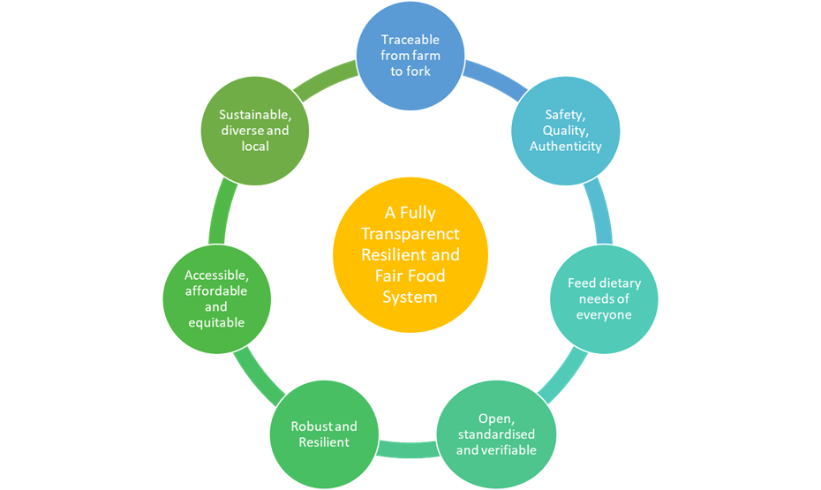

Vision Theme | Detailed statements
Traceable from farm to fork | A digitalised system which allows consumers to track their food and review verified information on food provenance, ingredients, production steps, the route to finished product, nutritional value, environmental footprint and fairness measures, to make an informed decision, but sensitive information is independently verified.
 | A food system that produces enough and affordable high quality, safe and authentic food food in an ecological and sustainable way in order to feed the world's population with a fair distribution even in times of crisis
 | Food can be traced at any moment with all information readily available to the governing body
 | Independently verified food labelling
 | Open, accurate and readily available information for any stakeholder, from farm to final consumer, providing all details on the ingredients, sourcing of raw materials, method of production, environmental costs, amimal welfatre, fairness to people involved, route, actors involved, nutritional information and any 'watch-outs'
Safety, Quality and Authenticity | A food system that oversees, governs and gaurantees the complete traceability, quality and safety of food, without tampering and verifies mandatory information and claims on food labelling and ensures true cost accounting
 | stem has enough check points to remove damaged goods (e.g. spoiled, high bacteria load etc) before they are sold..
Feed dietary needs of everyone | A food system that produces enough and affordable high quality, safe and authentic food food in an ecological and sustainable way in order to feed the world's population with a fair distribution even in times of crisis
 | A system that under all pressures, shocks and emergencies has the ability to stay alive providing food security and adequate amounts of top quality food and food services
Open standardised and verifiable | A food system with clear mission & vision well explained and understood by all parties and all actors willing to share information for the transformation of the system
 | A robust, standardised and independently verified traceability system
 | All actors together rule the food chain
 | Independently verified food labelling
Robust and Resilient | A system that under all pressures, shocks and emergencies has the ability to stay alive providing food security and adequate amounts of top quality food and food services
Accessible, affordable and equitable | A system where all parts of the food chain get their fair share, where food is distributed and accessible for everyone to meet their basic needs, working conditions are safe and costs are not left for future generations to pay.
 | Affordable nutritious food available easily and locally, with fair payment and pricing along the food chain and respects the environment, animals and workers
 | Food system that doesn't take more than it gives (less food waste- better environment)
 | Profits and benefits are share equally across the players in the food system
 | The revenue of the value chain should be spread over the entire system.
Sustainable, Diverse and Local | A diversified food system with high genetic diversity and locally adapted breeds without over-reliance on any one major ingredient, supplier or source
 | A food system that produces enough and affordable high quality, safe and authentic food in an ecological and sustainable way in order to feed the world's population with a fair distribution even in times of crisis
 | A system that relies more on locally produced and environmentally friendly products and is able to adapt to climate change,
 | Food system that doesn't take more than it gives (less food waste- better environment)

7.2.3c Barriers and Challenges to A Fully Transparent, Resilient & Fair Food System
 | 1  Not a cause | 2  Insignificant cause | 3  Slight cause | 4  Significant cause | 5  Very significant cause | I don't know | Total Responses
Growing population | 19 | 16 | 48 | 52 | 40 | 4 | 179
Intensive industrialised food production systems | 5 | 15 | 23 | 66 | 66 | 4 | 179
Food Specialization (a small number of plant and animal species supply 90% of the worlds calories) | 8 | 14 | 34 | 59 | 54 | 11 | 169
Global food supply chains | 2 | 7 | 23 | 63 | 76 | 8 | 171
Complex food supply chains | 2 | 7 | 22 | 66 | 71 | 11 | 168
Competitive culture in the food system | 11 | 14 | 37 | 42 | 63 | 11 | 167
Lack of trust | 10 | 22 | 34 | 41 | 60 | 12 | 167
Climate change and emerging risks | 7 | 12 | 31 | 44 | 78 | 7 | 172
Western Diets | 15 | 20 | 47 | 43 | 44 | 9 | 169
Food Waste | 8 | 9 | 27 | 55 | 73 | 6 | 172
Malicious and opportunistic individuals | 2 | 10 | 42 | 44 | 59 | 19 | 157
Organised crime | 11 | 24 | 40 | 51 | 34 | 18 | 160
War and Conflict | 1 | 10 | 33 | 57 | 73 | 6 | 174
Policy and governance | 0 | 5 | 19 | 52 | 94 | 10 | 170
Lack of education and training | 1 | 8 | 36 | 64 | 64 | 7 | 173

7.2.3d Do you think there are any additional root causes or reasons why we do not have a fully transparent, resilient and fair food system?
Category | Theme | Illustrative Quote(s)
Economic | Capitalism driven by profit | In many cases, capitalism tries to make profit based on superiority of one system over the other.
 |  | Capitalism
 | Growing competition and cost for energy | Energy consumption in current food system (10 Cal petrol for 1 cal of food) in a world of growing scarcity for oil.
 | It is too expensive for our current lifestyle | I think it is too expensive for our current life style.
 |  | It would be more effort for all participants i.e. cost extra money
 | Low income people have limited access to healthy food | Socio-economic issue. Low income people had limited access to healthy food.
Primary Production | Lack of knowledge and time for farmers to implement innovations and best practices | Lack of knowledge and time for farmers to implement innovations and best practices for a more resilient system.
Food System / Industry | Complex food system makes transparency difficult | Because of the "nature" of food system (and society in general). I don't think that food systems have been developed to be fully transparent, resilient and fair. We can always try to improve our current food system and to go closer to it but we will never actually get there
 |  | Insufficient control of food when transferred from a local to a global market.
 |  | The food system significantly varies from region to region, between countries and continents. The bad financial situation in some countries has a great influence on the absence or low level of a transparent, resilient, and fair food system.
 |  | E.g. processed food is easier to sell, if the consumers doesn't know whats in there. Supply chains are so big nowadays, that traceability might be a problem, because producers don't know where the food in the package comes from in the end, or it would be incredibly hard to list everything.
 |  | Long value chains and lack of transparency on margins sharing.
 | Current food system promotes privitization, exports and limited transparency | Promoting privatization and exports despite low livestock and crop production.
 |  | People are used to not having it.
 | Reactive industry with dominant actors focusing on short term results | short termism of dominant actors
Brand Owner | Excessive pressure on profits | pressure on returns and profitability expected from investors and financial markets for food companies is excessive
 |  | Market pressure dropping down prices at production point.
 | Economic greed with profits over accountability | Secrecy in commercial practices/ supply chains to protect profit over accountability
 |  | Economic greed
 |  | Economic concerns rank first worldwide, fairness, ethics and transparency far down the rankings
 |  | Intransparency is a pillar in a lot of strategies to create the advantage.
 |  | Market mechanisms connected to growth-economics
 |  | Money. People. Give the second the first, and they will always try to make things a bit "foggy" to have even more for themselves. Then they will slowly watch it to decrease the value. :) I'm all in for transparent, fair system. But it will be hard. Especially if you plan to include the information about the levels of imidazoles in caramel colour (cola drinks) and aflatoxins in several types of chocolate spread. In this country, there are efforts to avoid all goods from one certain company - and even that is really hard, they mask it very well.
 |  | trade, I think that trading with food is one reason why we do not have a fully transparent, resilient and fair food system, globalization, in the end, all of the stakeholders want to earn money (it's all about the money), lifestyle in "rich" countries (people spent a lot of money on luxury goods)
 |  | Some people are rather aiming at high income/monetary benefit (instead of aiming a healthy planet and sustainable agriculture)
 |  | generating private gain and at the same time a high social price that everyone pays
 | Competitive culture often brings cheap, unsustainable and low quality products to the market, and harms fragile actors | Competition to lower food prices that disadvantage the most fragile categories of society,
 |  | In order to have a more transparent, resilient and fair food system, the major food production companies need to take an interest into investing in such a system and to be willing to suffer losses during the transformation to the better system. Unfortunately, as all industries, the food industry is mostly concerned with profit and creating a product that can outcompete its competitors, often bringing cheap, unsustainable products to the market, which often both lack to necessary health benefits and are often bad for the environment.
 | Power imbalance and inequity | Oligopoly in the retail and distribution sectors.
 |  | Inequity across the supply chain (vs farmers).
Power imbalance/asymmetry (concentration and concentration of power in the agri-food sector, see e.g. https://www.ipes-food.org/_img/upload/files/Concentration_FullReport.pdf)
generalized inequalities

 |  | Monopole
 |  | From what I know, retailers are asking for a too large share of margin in the value chain pûtting pressure on food companies and farmers
 |  | Unfair access to resources
 | Fear transparency is expensive and a competitive disadvantage | Fear of transparency being expensive and a competitive disadvantage. sway and money are always a major cause in different systems, I think
 | Food pricing does not embed externalities | Food pricing that does not embed externalities
 | Lack of transparency on margin sharing | Long value chains and lack of transparency on margins sharing.
Consumer | Disengagement with the food system | It would be more costly and people just want to get more money, not caring for anything else. Issues in education, such as parents not being open to their kids about the slaughtering process but still serving steak for dinner.  lack of consumer's interest and economic possibilities
 | Lack of critical consumers | Lack of critical consumers.
Political | World trade organisation agreements do not foster sustainability | Commercial conditions derived from the World Trade Organization agreements
 |  | WTO rules that do not foster sustainability and food pricing that does not embed externalities
 |  | It is also a matter of justice and democracy.
 | Food producers lobby against change for economic interests | Lobbying by food producers and economic interests
 | Policy and Government support just the big brands | Policys and governments are not interessted to Change their global food chains, and support just the big brands. Normal farmers can not keep up with them.
Resources and infrastructure | Poor digitalisation and interconnectedness | Lack of information/data on Food Systems due to poor digitization and interconnectedness
Collaboration and Partnerships | Academic and industry consortiums | Academia and industry consortium is important step for transparent resilient and fair food system.
Funding Landscape | Financial investments need for transformation | Financial investments
Fairness | Food system involves exploitation of humans and animals | It can’t be fair as long as it is based on the exploitation of humans and animals
Other | Food Prices do not embed externalities | Nature has no value, leading to so cold 'externalities' being unacounted for"
 | Clarity around food system associated resources | Foods and food-system associated resources are in the meanwhile a matter of speculation.
 | Western lifestyles | People in the Western countries are not willing to change their lifestyle
 |  | Cultural reasons

7.2.3e: All trends and drivers rated by questionnaire respondents
 | No or Insignificant Impact | Short term impact on net zero agenda  (2023-2025) | Medium term impact on the net zero agenda  (2025-2030) | Long term impact on the net zero agenda  (2030-2050) | Total Responses
Growing population | 10 | 19 | 37 | 91 | 157
Rapid urbanisation and growth of megacities | 7 | 22 | 63 | 64 | 156
Migration of people to other regions | 15 | 42 | 61 | 40 | 158
Refugee Crisis, Human trafficking and Exploitation | 14 | 59 | 61 | 25 | 159
Labour and skills availability | 16 | 60 | 54 | 28 | 158
Work stress and long working hours | 38 | 59 | 39 | 19 | 155
Flexible working arrangements | 62 | 42 | 37 | 18 | 159
Rising middle class | 35 | 26 | 67 | 31 | 159
Rampant Inflation and increases in expenditure for the food industry | 3 | 97 | 41 | 18 | 159
Rampant Inflation and increases in non-food expenditure for consumers | 10 | 95 | 39 | 15 | 159
Poverty, inequality and social security | 4 | 61 | 46 | 48 | 159
Increasing social innovations | 22 | 30 | 62 | 43 | 157
A movement towards locally-sourced goods | 13 | 37 | 71 | 38 | 159
Environmentally Conscious Consumers | 9 | 33 | 71 | 45 | 158
Health Conscious Consumer | 10 | 40 | 67 | 40 | 157
Welfare Conscious Consumer | 15 | 36 | 67 | 39 | 157
Climate Change | 2 | 47 | 41 | 68 | 158
Availability of natural resources | 2 | 33 | 49 | 73 | 157
Availability of raw materials | 3 | 41 | 54 | 60 | 158
Use of crops for energy or non-food materials (e.g. fiber, for textile) | 8 | 33 | 75 | 43 | 159
Cost and availability of cheap fossil fuel energy | 5 | 68 | 48 | 36 | 157
Availability of raw materials | 3 | 41 | 54 | 60 | 158
Use of crops for energy and non-food materials (e.g. fiber, textile etc.) | 8 | 33 | 75 | 43 | 159
Cost and availability of cheap fossil fuel energy | 5 | 68 | 48 | 36 | 157
Social media and influencers | 35 | 79 | 37 | 7 | 158
Availability of new technologies | 8 | 39 | 74 | 38 | 159
Digitalisation | 7 | 51 | 69 | 32 | 159
International Trade | 5 | 62 | 65 | 27 | 159
Policy | 6 | 54 | 59 | 40 | 159
War and conflict | 3 | 97 | 34 | 23 | 157

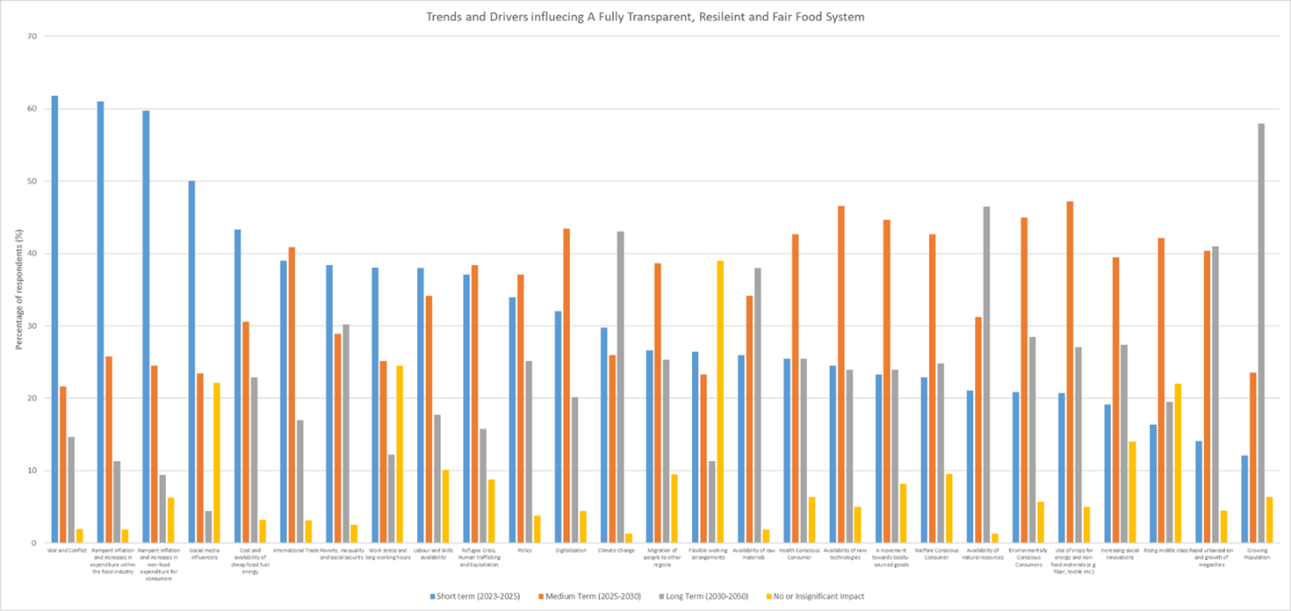

7.2.3f Are there any other trends occurring across the globe that are impacting on a fully transparent, resilient and fair food system?

Category | Theme | Illustrative Quote(s)
Society | Crisis situations | Pandemics/epidemics
 |  | Pandemics, animal health issues
 |  | crises are also chances and drivers for innovations
 | Social movements | Social movements
 | Human Passivity | Another factor is, maybe, human passivity. Young people were told, in their childhood, that a simple political demonstration can change the world. So they tried and found otherwise. Now they are emo-sitting in the corner of facebook, no hope, no ideas, no activities. So it is quite possible that some politician will come, make this his flagship, and everybody who wants to do something about it will abandon the ship, like the environmental-friendly people did after the Greta affair, and only other politics will remain, talking endlessly."
 | Aging population who appreciate they can afford food and do not value sustainable, fair and transparent food system | ageing population - some may still come from times and places of war, and they will just appreciate that they have and can afford food, but will not (be accustomed or able to) value sustainable, fair and transparent food system.
Primary Production | Animal health issues | Pandemics, animal health issues
Food System | Reorganisation of the food system | (+) Bottom up reorganisation of supply chain (relocation in territories, short circuits..)
Consumers | Distrust in digital technologies due to misuse for surveillance of citizens | The misuse of digital technologies for surveillance of citizens and consumers lead to distrust, also for the use of digital technologies for ensuring transparency in the food system
Policy | World Trade Organization agreements | World Trade Organization agreements
 | Lobbying against change negative impacts food system transformation | (-) Lobbying against change.
 | Policy is negatively impacting food system transformation | Policy has continuous negative effect, I marked that it could maybe have positive effect in far future (naive, I know).
Other | Status quo is not towards a fully fully transparent, resilient and fair food system? | (-) Status quo in Finance

7.2.3g: All market needs rated by questionnaire respondents

 | Not Needed | Urgently Needed  (2023-2025) | Fair Need  (2025-2030) | Low Need  (2030-2050) | Insignificant or Long Term Need  (Beyond 2050) | Total Responses
Increased Productivity and Profitability | 21 | 24 | 64 | 25 | 10 | 144
Improving food safety | 5 | 39 | 42 | 21 | 5 | 144
Ensuring integrity of food supply chains | 0 | 87 | 49 | 8 | 2 | 146
Food produced to the highest ethical standards | 0 | 78 | 49 | 14 | 5 | 146
Fair Food Prices | 0 | 106 | 34 | 4 | 2 | 146
Nutritious food | 3 | 68 | 59 | 13 | 3 | 146
Assuring fair revenues to primary production sector | 1 | 104 | 28 | 13 | 0 | 146
Labour Availability | 3 | 59 | 59 | 22 | 2 | 145
Improving wages and working conditions | 2 | 86 | 48 | 10 | 0 | 146
Local sourcing | 2 | 73 | 59 | 11 | 0 | 145
Sustainable farm management techniques | 0 | 92 | 46 | 5 | 3 | 146
Achieving net zero food production | 3 | 51 | 65 | 23 | 2 | 144
Water management | 0 | 104 | 39 | 11 | 1 | 146
Environmentally friendly alternatives to agricultural chemicals (e.g. fertilizers, pesticides, insecticides etc.) | 0 | 80 | 51 | 14 | 1 | 146
Resiliency to changing weather patterns and natural hazards | 1 | 62 | 67 | 15 | 1 | 146
Farm machinery and robotics | 3 | 13 | 72 | 44 | 13 | 145
Data analysis and precision production | 4 | 29 | 70 | 38 | 4 | 145
Reduction in contaminants (natural or artificial) | 2 | 66 | 59 | 16 | 1 | 144
Zero emission energy sources | 2 | 71 | 53 | 18 | 1 | 145
Quantifying emissions | 4 | 62 | 59 | 16 | 4 | 145
Sustainable packaging | 0 | 87 | 48 | 9 | 2 | 146
Smart labelling | 2 | 45 | 59 | 35 | 5 | 146
Traceability and provenance | 0 | 69 | 68 | 6 | 1 | 144
Food waste reduction | 0 | 117 | 25 | 4 | 0 | 146
Resource efficiency | 0 | 100 | 40 | 6 | 0 | 146
Knowledge and skills training | 0 | 79 | 50 | 15 | 2 | 146
Consumer Education | 0 | 87 | 47 | 9 | 1 | 144
Consumer insight | 2 | 57 | 65 | 20 | 2 | 146
Protecting the food system from opportunistic and malicious individuals or organisations | 0 | 74 | 57 | 11 | 4 | 146
Alternative protein sources (food and feed) | 3 | 43 | 64 | 25 | 10 | 145
Access to innovation and technology in the food system | 0 | 40 | 83 | 18 | 3 | 144
Digitalisation of the food system | 5 | 23 | 68 | 43 | 6 | 145
Big data and artificial intelligence | 6 | 12 | 62 | 52 | 13 | 145
Evidence based policy | 1 | 73 | 50 | 17 | 4 | 145
Governance and suitable guardians in the food system | 2 | 70 | 53 | 15 | 6 | 146

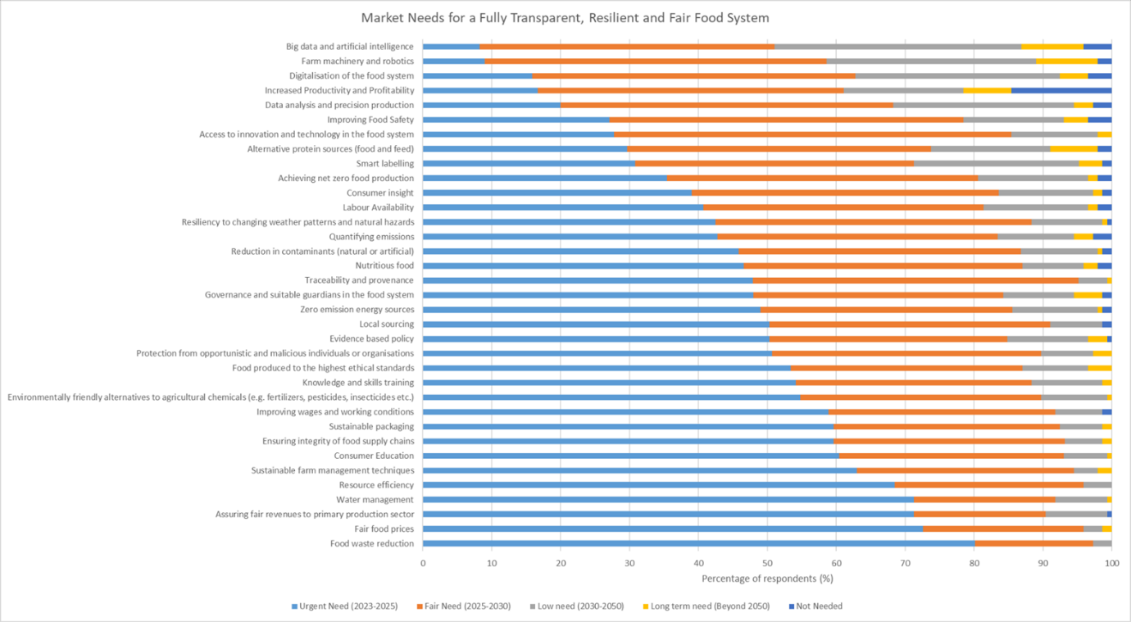

7.2.3h: Within the agrifood sector, do you think there are any additional needs or challenges in achieving a fully transparent, resilient and fair food system?
Category | Theme | Illustrative Quote(s)
Primary Production | Regenerative agriculture | Regenerative agriculture and agro-ecology in general go beyond 'sustainable agriculture' (largely greenwashed) to achieve real resilience.
 | Agro-ecology
 | Carbon Farming Schemes | Carbon farming schemes and policies towards more sustainable agricultural practices will be key and central to future fair and transparent food systems.
Consumer | Consumer education on how to choose sustainable products when grocery shopping | Education young people how choose sustainable products during grocery shopping
Consumer | Consumer interventions to reduce food waste | Cooking in the workshop kitchen to learn people how to avoid wasting food and limit meat consumption (e.g. at a Food Bank)
 | Consumer education interventions aimed at reducing meat consumption | Cooking in the workshop kitchen to learn people how to avoid wasting food and limit meat consumption (e.g. at a Food Bank)
Policy | Policies towards more sustainable agricultural practices | Carbon farming schemes and policies towards more sustainable agricultural practices will be key and central to future fair and transparent food systems.
Policy | Governance and punishment for unfair, unsustainable or non-welfare sources | unfair, non-sustainable processes need to be traced and financially punished (e.g. the products from unfair, non-sustainable, non-welfare sources need to be very, very expensive for the consumer)
Research and research translation | Evidence based information | Much misinformation and misuse of metrics to demonise the livestock industry when large multinational corporations are promoting the sale of highly industrialised and highly artificial vegan substitutes and claiming that these factory-produced products are better for the environment
Fairness | Normative regulation on profit margins | Normative regulation of the profit margins of the various commercial agents of the agri-food sector
Fairness | True Cost Accounting | True Cost Accounting, shifting policy incentives, paradigm shift towards agroecology (https://www.ipes-food.org/_img/upload/files/UniformityToDiversity_FULL.pdf), integrated food policy making
Transparency | Fear of a fully transparent food system | Quis custodiet ipsos custodes? It all sounds great, but we all still remeber the results of raids against supposed hackers and distributors of illegal software that enabled some big-but-not-that-good companies to get rid of competition, and we know how both REACH and Food Alcohol Law removed a lot of smaller companies from the market as they were not able to pay for required stuff (plus, in my country it was totally useless, we had more strict regulation for toxic compounds limits then REACH required). So a lot of people will be against it from the principle, because they will see it as another means to make trouble to those to who someone want to make trouble, no matter if their products are good or not. Look at the laws about personal data protection: it made a lot of trouble, but the bank where I had a temporary account during Erasmus happily informed me a month ago that they are now stealing all actual information about me from some register they managed to get to, so if I move, I do not have to tell them, and I'm helpless against it. I'm all in, but I'm the customer. Producers will be afraid of this.
Capabilities | Carbon farming platforms | carbon farming platforms may have much more impact and importance than traceability platforms"
Other | Pollution should be part of the debate | Pollution (air, soil, food) is largely ignored from the debate (carbon myopia) though it is critical for the health of the whole system (eg. no bee no food, no resilience)"

7.2.3i: All opportunities rated by questionnaire respondents
 | Urgent Priority (2023-2025) | Fair Priority (2025-2030) | Low Priority (2030-2050) | Insignificant Priority (Beyond 2050) | Not a priority | Total Responses
Sustainable farm management | 99 | 39 | 3 | 0 | 0 | 141
Sustainable Aquaculture production | 87 | 42 | 11 | 0 | 1 | 140
Achieving net zero production | 46 | 68 | 20 | 2 | 5 | 134
Improving animal welfare | 85 | 43 | 11 | 2 | 0 | 139
Water management | 101 | 34 | 5 | 1 | 0 | 140
Controlled environment agriculture and vertical farms | 42 | 52 | 42 | 3 | 2 | 136
Reduction in contaminants (natural and artificial) | 66 | 54 | 29 | 1 | 1 | 140
Integrated Production Systems | 33 | 74 | 29 | 2 | 1 | 136
Biological based crop protection | 56 | 57 | 24 | 2 | 1 | 137
Microbiome technologies for crops and soil | 35 | 72 | 25 | 6 | 2 | 132
Gene editing technology | 17 | 47 | 45 | 17 | 14 | 109
Plant-based food alternatives | 49 | 49 | 23 | 12 | 8 | 121
Cultured and lab-grown food | 19 | 37 | 43 | 29 | 13 | 99
Synthetic Biology | 8 | 40 | 50 | 30 | 13 | 98
Robotics, drones and automation | 14 | 55 | 49 | 15 | 8 | 118
Food sensing and processing | 21 | 61 | 47 | 6 | 5 | 129
Food Preservation and Smart Food Packaging | 53 | 64 | 20 | 1 | 3 | 137
Food Labelling | 55 | 59 | 24 | 3 | 0 | 138
Supply chain distribution and management | 64 | 58 | 11 | 5 | 1 | 133
Optimizing local food supply chains | 97 | 31 | 11 | 2 | 0 | 139
Optimizing global food supply chains | 63 | 56 | 14 | 6 | 2 | 133
Waste Management and Circular Economy | 100 | 35 | 3 | 3 | 0 | 138
Social Innovations | 39 | 62 | 28 | 5 | 6 | 129
Digital marketplaces | 16 | 55 | 51 | 12 | 7 | 122
Consumer Insight | 50 | 60 | 23 | 5 | 2 | 133
Consumer behaviour and diets | 71 | 58 | 10 | 1 | 1 | 139
Data and value-chain integration | 35 | 61 | 34 | 7 | 4 | 130
Robust handheld devices for control of food contaminants | 24 | 63 | 36 | 12 | 5 | 123
Artificial Intelligence | 9 | 56 | 50 | 14 | 12 | 115
Computer Vision | 9 | 47 | 55 | 17 | 12 | 111
Blockchain | 8 | 43 | 51 | 19 | 19 | 102
Machine Learning | 13 | 53 | 45 | 17 | 12 | 111
Internet of Things | 11 | 44 | 42 | 24 | 20 | 97
Virtual Reality | 2 | 25 | 53 | 27 | 34 | 80
Business models and systems | 38 | 52 | 31 | 14 | 6 | 121
Evidence-based Policy | 82 | 40 | 12 | 6 | 1 | 134
Nanotechnology | 5 | 47 | 54 | 24 | 12 | 106

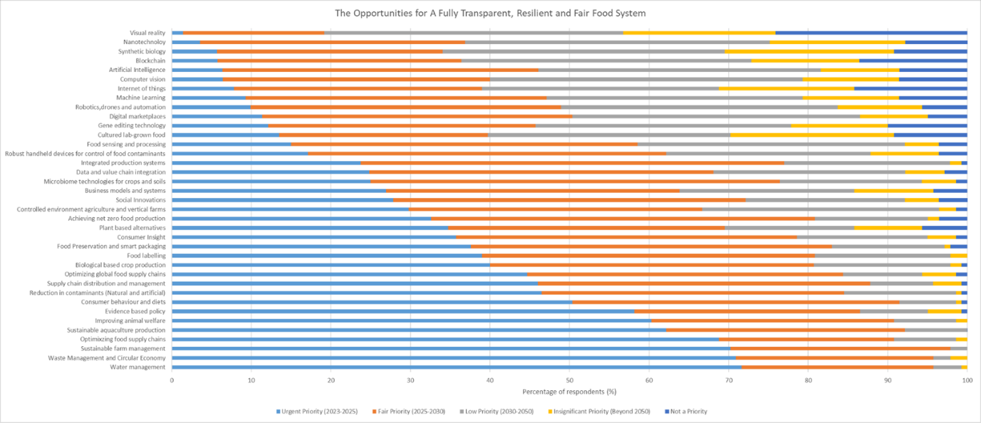

7.2.3j: Are there any additional value creation opportunities in order to ensure a fully transparent, resilient and fair food system?

Category | Theme | Illustrative Quote(s)
Sustainable food production | Agroecology | urgent to massively invest in agroecology (against industrial ag), including investing in farmer welfare. farming must become a desirable occupation to attract young talents and multiply by two the number of farms in EU. farming has the potential to create millions of jobs in europe, and massively impact positively under agroecological approach.
 | Carbon farming schemes | Carbon farming schemes + attached regulation & standards
Transport and distribution systems | Environmental-friendly, energy-low transport systems | Environmental-friendly, energy-low transport systems (e.g. unmanned aerial vehicle=drone)
Collaborations and partnerships | Increased the number of stakeholders with a shared mission | Increase the number of stakeholders and professionals involved in the purpose of ensuring a fully transparent, resilient, and fair food system.
 |  | shifting paradigms
Policy | Policy incentives for diversified, local and agroecological systems | Policy incentives towards diversified, local and agroecological systems (https://www.ipes-food.org/_img/upload/files/UniformityToDiversity_FULL.pdf)
Fairness | True cost accounting | True Cost Accounting, shifting paradigms and policy incentives towards diversified, local and agroecological systems (https://www.ipes-food.org/_img/upload/files/UniformityToDiversity_FULL.pdf)

7.2.3k: Enablers for A Fully Transparent, Resilient and Fair Food System

 | Urgent Priority (2023-2025) | Fair Priority (2025-2030) | Low Priority (2030-2050) | Insignificant Priority (Beyond 2050) | Not a Priority
Policy and legislation | 73 | 49 | 11 | 6 | 139
Knowledge and skills | 56 | 58 | 23 | 1 | 138
Resources and infrastructure | 59 | 55 | 22 | 1 | 137
Funding landscape | 38 | 53 | 38 | 8 | 38
Collaboration and partnerships | 44 | 63 | 21 | 9 | 137
Public Engagement | 58 | 44 | 29 | 8 | 139
Research and Innovation | 68 | 46 | 20 | 3 | 137

7.2.3k: Do you think there are any other enablers required to deliver a fully transparent, resilient and fair food system by 2050?
Category | Theme | Illustrative Quote(s)
Primary Production | Carbon sequestration | The only relevant strategic technology is to get greenhouse gases stored back to the ground. Even if the situation could be frozen to the status 2022, it would be too late for some parts of the world (I don`t think that Bangladesh can manage an annual flooding event over decades). What fairness means in this context stays unclear.
New Technologies | Biotechnology | the emergence of biotechnologies in food will have a deeper impact than we think on re-localisation of supply chains and reduction of animal-based foods and the related impact they have on food systems"
Collaboration and Partnerships | Stakeholders in the food system working together | The implication of the stakeholders and food system professionals
 | Grassroots movements for resilient, decentralized and distributed food system | a key aspect is to give way more attention, and means of action, to grassroots movements, in territories as enablers of a resilient, decentralized and distributed food system. if large corporations remain the main stakeholders and beneficiaries of policies or funding, then improvement will only be marginal.
 | Shared vision and willingness to become fully transparent | collective / collaborative / cross-silos foresight projection is absolutely needed : where shall we go and how ?
 |  | By 2050? If you really wanted to do it, it is not (yet) forbidden. You could make your part of food system completely transparent now, and start to integrate others to your club, if you want to. Consumers will be happy for the info. There is some mandatory labeling anyway, so it as well could be usefull, and you could add more info to Internet. There is a banana farm like this that adds info from which farm this harvest is on every crate, and you can have a virtual walk there..... and it is nice. :) Resilient, this part might be harder, but even that won't be such a problem
Policy | Policy has to set the stage | Consumers and producers can ask for that => policy has to set the stage
Public Engagement | Consumer Education | Consumers need to be educated, the average consumer knows nothing about how their food is produced or where is comes from
Other | market's growth oriented imperatives | market's growth oriented imperatives
Other | Fully transparent may not be ideal for the food system | Just be carefull not to end like Linux, which was a totally wonderfull idea and now it has the hands tied firmly by its own sets of rules, enforced not by clever programers who wanted to share everything, but by a bunch of idealists who wants to enforce for enforcing, and they are not looking at the fact that the system cannot live like this."

7.2.3l: Can the food system become Fully Transparent, Resilient and Fair?
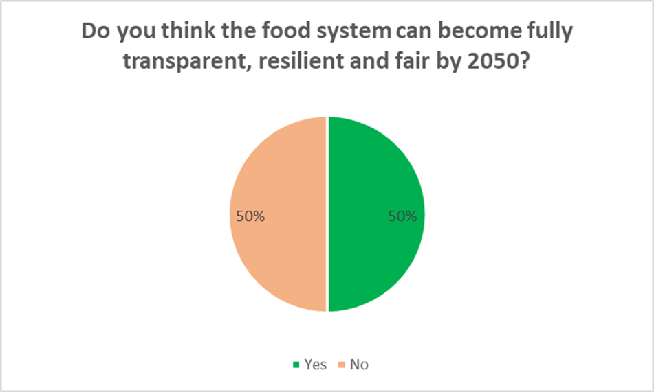

All reasons for and against a fully transparent, resilient and fair food system
YES | NO
increasing awareness, innovation landscape, emerging alternative production methods and sustainable farming initiatives | The sheer size of the ambition to become Fully across all 3 elements feels like a goal that will be forever out of reach.  Having a baseline set of metrics which progress can be tracked to become significantly better feels like a more realistic goal.
There is plenty of time to resolve all issues by then while the same time technologies excel very fast | Not fully but a large proportion could be.
Growing public/consumer awareness is creating pressure on markets toward a more local, sustainable production. Growing demand for alternatives to meat-based diets. Growing awareness for animal welfare issues. | No because a fully transparent resilient and fair food system is a utopia
location-adjusted food production would help to achieve this goal. Yet I think that the interest of single persons/industries/enterprises are not in accordance with a transparent and fair food system. | complex global system
At EU level, several factors are moving in that direction (shared food policy, FSE+, agricultural policies reforms, promotion of plant-based diets), as being dramatically linked to climate change, poverty, spread of CD and NC Diseases, and bad effects of globalization of food chains, if we want to survive, we must achieve all of the three missions. | complexity, too many factors
With increasing digitalization and integration of systems fuelled by increasing automation of data collection, analysis and data processing and improved technologies and public awareness, there can be a creation of such a food system. | Not enough incentives
I believe we have the tools, it is a matter to fully implement them to the food value chain in an efficient manner, which will imply obviously funding | In my opinion is not easy to reach a fully transparent, resilient, and fair food system in the circumstances reported by the United Nations Organization: "We are facing another perfect storm for global food systems, the result of a combination of crises: the war in Ukraine and the conflict’s impacts on two of major food exporters; the continuation of COVID-19 disruptions on global supply chains and slow and uneven recovery from the pandemic-related recession; climate shocks, including the droughts and heat waves that are hitting various regions of the world, from the Horn of Africa to China; and energy price shocks, which are adding fuel to the fire, with spiralling global inflation affecting food and fertilizer prices. This has revealed developing countries’ high dependence on food and fertilizer imports and the fragility of food and agricultural commodity systems. They have also underscored their centrality to sustainable development and poverty reduction". (from FAO www site)
we need to change, and a lot is possible | Vested interests, conflict and rapidly growing populations.
if we all want this, then yes | Too profit oriented
there is a possibility that the current, hyper centralized system's business model will not be able to adapt to the upcoming crisis (eg. cost of energy, temperatures, social instability...). if localised supply chains can emerge as alternatives, they might achieve the desired resilient state. | The system is too complex and difficult to control. The pieces that are possible to control are often in the hands of actors that have no interest in a transparent, resilient and fair food system.
Because we have the knowledge and solutions, what is lacking is the political will to implement them. | The counteracting forces (population growth, political instability in many countries, climate change) will require major efforts to even "keep in place” and will not allow for fast progress.
the current system has social, environmental and economic negative effects. the food system will become transparent, resilient and fair due to economic reasons. social and environmental problems are mainly economic problems. this is the reason why we should manage social and environmental problems! | There is a lot of barriers. The main driver of all the players on the food supply can is profit. It would need a lot of investment, support from the government. It is too complex issue.
It has to, in order to retain a liveable planet... | Autocracies in developing countries
Even if there are lot of signals happening that would lead me to say the opposite, it Is a hope rather than a statement. Just as there have been major social and economic developments throughout history, I hope that man will be able to cope with this one as well. | This is a huge task requiring a global response. The complexity lies within the complex nature of food - a need for all humans and animals, yet also a source of profit and an emotional source of pleasure/pain. The position the food system is currently in has taken years to develop, so I believe a 50+ year plan is needed to ensure this target can be achieved in a way which is truly sustainable (socially, economically, environmentally).
it's an urgent need | Because ongoing multinationals control over food chains is too broad
I believe in the power of innovative solutions appearing around the world that can help achieve this goal. | On the one hand, it is a highly complex, globally active system that is not so easy to understand, and on the other hand not everyone involved is honest and fair
transparent, resilient and fair food system is crucial in the pursuit of sustainability goals | As said, to my opinion, fairness can be a matter to small societal units, families, maybe tribes or clans. Complex neoliberal trade and speculation will never take responsibility for the entire food system. And since in most neoliberal transactions the individual advantage is seeking, the system will stay in transparent and instable to some extent. Stressors from outside are triggers of disasters but they manifest the inability of mankind to file mutual preparative action. The discussion on resilience is often a discussion of those that haven`t been fully hit yet. I am optimistic that some populations will do better than others, more should not be awaited.
If we learn to cooperate and not act greedily for profit, then it can come true. The problem is not solved with technical innovation, but with social and structural innovations. | It will not be a priority in a more and more unsecure global scenario (wars, pandemics, disasters)
Consumers ask for it | Inequality is growing
there is a demand for it with education people want to know more | High system complexity needs knowledge, cooperation and very committed public and private actors, and aware citizens.
because we need it, given the impact food has on our global sustainability | Big differences (financial, cultural, education, etc) around the globe.
If action is taken by governing bodies, funding agencies and researchers we can provide new technology solutions, as well as ethical treatment of the environment, humans and animals in food production. We will need to break up malicious groups, develop resilient strategies for sustainable food production, identify new emerging hazards to the food system, and support workers through proper compensation. | It depends too much on policy
I think it is a necessity in order to provide enough food for the growing population to avoid future conflicts about it. | not possible to ensure, not possible to avoid e.g. crimes (food fraud,), no influence over 3rd countries etc., etc.
Yes, but only in some sectors and perhaps not fully and globally due to its complexity and dynamic nature and that is spans many cultures. | It will take a lot of time to make all players in the food chain, from the primary producer to the politicians work together in a fruitful way; There will always be toxic company, person (politician), groups that will hinder a fully transparent, resilient and fair food system
Because it is possible but would require reigning in rampant bad business practices | better than now, but never fully
I think everybody who really wanted could make their part of food system transparent in 6 months.  We buy this, we plant that, and look how wonderful food we have for you. The factory is here. And we have this waterwheel still in work (I saw that in Jameson whiskey plant), but now we also use some electricity. The food was tested in this lab according to this method, and there is only 0.00000... of aflatoxins in it. We do not use caramel colour, the colour is this one, not toxic.  The problem is, many companies will not want to show this, because it won't sound so nice.  So if you want to enforce the transparent system, that will be another story. You can start it, and if it is good, people will support it. But someone still pays for Windows and Apple, although there is no need to do that. Because they want to do something that they are not allowed, by the rules, to do with Linux.  I believe in 2050, the transparent system will be either everywhere, or somewhere in the corner and not very happy. It depends on the people who will make it useful and viable, or just annoying. | Because the humankind is unfortunately rather short sighted with their big decisions and politicians are too much of cowards to make the big necessary decisions.
The knowledge and expertise are there. It will be a public and policy decision to do it | Because we do not care enough as humans
due to various crisis -> more pressure from customers to politicians | Most people do not care where their food comes from - they just want to have plenty of it.
We have the knowledge, the means and the technology - only thing that remains is education of decision-makers and of consumers, and a stringent system to trace and punish unfair, non-resilient, non-welfare, non-transparent production systems or products. | Transparency is the biggest issue. I don't think that the global players will "show their cards".
interdepartmental support and working with, then it is achievable. I would add the knowledge and understanding of this needs to be trained out, so everyone is aware | to little progress in risk mitigation; how it stands by today, climate catastrophe will be a disruptive impact! Greed and speculation are the money-making attitudes of too many partners in the systems
Rather sooner than later the impacts of our food system as it is now will have negative impacts and consequences. I strongly believe that humankind is able to make the food system fully transparent, resilient and fair by 2050 - the question is if the key stakeholders and politicians want to. I also believe that transparency would lead to increased consumer awareness, which could result in a reduction of food waste and increased purchases of locally and sustainably produced products and so on. | Because companies will always want money and will always buy politicians to prevent a transparent food system.
Europe will get their target 2050 through H2020, | Globally it doesn’t seem like that because the underdeveloped countries are far away in this respect because economy crisis.
I am optimist. | Globalisation, trade/profit, in some nations they do not have a solid political environment, and this is a very important basic to achieve a fully transparent, resilient and fair by 2050
I really hope so - I see a lot of re-thinking in people and try to transmit the message, how important it is to buy local, reduce waste and meat consumption. | Profit orientated companies (concerns) rule the politics.
It is definitely possible, but it depends on whether the governments will provide the funding | I wish it would, but I fear it will never happen because people are idiots.
In case of economic breakdown | to complex food chains
because there are drivers of innovation both in science and research and as well in the public! Policy makers need to address this as the public opinion on this topic is in a flux. Nevertheless, a global traceable system for food will be hard to implement. | People are too used to the way it is. I think it would take a while longer.
Because I am feeling optimistic that some things might change in the EU. Globally, this will not happen by 2050, but locally it might/could. | Lobbyism’s, people in charge are mainly after money and their own wishes
Pressure from consumers | Because the current political situation across the world won't allow all countries to participate in this system and I think it takes longer than 2050 to change the political structure in many countries
Protože do roku 2050 je ještě dost času, za tu dobu se toho dá stihnout hodně, pokud se chce.... | Impossible
Weil der Mensch sich grundsätzlich erhalten will und das geht nur überall gemeinsam und gleichzeitig.  Jeder sollte im Ernährungssystem die positiven Erfahrungen der anderen wissen und für sich, wenn möglich, anwenden. | As long as economic interests prevail and there is no lobbying for poor countries and consumers, the system will never be transparent, resilient and fair.
I think it is already on a good way, also technology advances a lot this age. | Unfortunately no because people don’t care
Because it’s really a no debate. If there is not significant progress towards this state, there will be shortages and hunger in locations where it won’t be hidden. | Not enough focus by governments, big private sector
Because we have all we need: knowledge, technology, and we must optimize the use of resources. | Only 25 years to go, it is a short period to make such a change.
 | these parameters are influenced by way too many factors, which all interact way to complex and unpredictable with each other to become "fully" transparent, resilient and fair, so this might never happen. but if there is a chance (and i am sure there is) that the food system becomes "more" transparent, resilient and fair (on a worldwide scale) than it is today, it would be a goal worth aiming for
 | we are not even able to keep the promises made on the SDGs. The food system is too concentrated in the hands of a few and generates enormous social inequalities and inefficiencies
 | I hope it will be better than right now, but I don’t see it completely changed
 | policy and companies are not extremely interested in it
 | As long as policy maker cater solely to the industry, there will be no transparency and fairness. Policy makers need to make evidence-based decisions benefiting the population, primary producers and the economy
 | Because there are still many factors on a global and local scale (social, economic, political, cultural ...) that hinder its achievement
 | Politics, private persons not interested because reducing of profits
 | I think that really a lot has to be changed/has to change (concerning the government, the opinion, attitude and behaviour of consumers...) and I'm afraid that also in the future there will be only a small part of all consumers who really care about that topic. Maybe the situation will get slightly better in the future, but not as much as it should.
 | There must be trade-offs between these concepts. An obvious one would be that if everything is completely transparent, then it might be less resilient?
 | I believe it will be much better than it is now, probably even better than we expect it to be, since the awareness for the topic is rising with each year. However, I doubt that we can reach a point where we can say that any industry or system is fully transparent, resilient or fair.
The 3 components are different in nature and will need separate support. What can be achieved needs to be contextualized:
* Food integrity could be achieved by 2050
* Resiliency to disruption can and must be improved by 2050
* strong doubts that fairness would be achieved by 2050 given the economic dynamics and what the legislators can do. Significant efforts are needed if this is an EIT Food ambitions. EIT Food has to define what is the concrete impact that is aimed to be achieved for this dimension.
 | Globally speaking, the politics alone make this impossible, especially considering where politicians' priorities lie. Global warming has been a known increasing danger for decades and yet those with the power to implement significant change have no interest in doing so. In addition, people are and will always be opportunistic, and in the capitalist society that is most of the West (and presumably a large factor in global food consumption), both consumers, and large corporations which sell/market the products will always exist which are interested only in making a profit. As the influence between such cooperations and the government is not a one-way street, this will likely further decrease chances of relevant policy changes.
 | The required changes, starting by a comprehensive policy and regulatory framework, as well as an agile funding landscape helping specially farmers and food small SMEs adopting innovation and sustainable practices. might take time. Producers face strong pressure on working hours and limited time and skills to change how they operate unless they have extra incentives and support.
 | I think too many players see maximum profit before fairness as their priority
 | I am not convinced that people will change their behaviour, everybody likes their social status. How 1 million of people can change 4 billion who are producing 4x more waste than the others. I am very sceptical
 | I wish I could answer yes, but I think there are many flaws in the capitalist system we live in which will not allow us to have a fully transparent, resilient and fair food system. Consumers are not willing to pay for fair prices (especially with current inflation), businesses are not willing to pay their workers fair prices and to fully disclose their activities. Furthermore, global corporations (big players like Nestle, Unilever, Cargill) have insufficient insights into their supply chain and mainly work with middleman rather than with farmers directly. There is also no pressure from the policy side to make any radical changes to the system.

